**Music Radio**

Backend:

1452656 lvjinhua 18201901762 happyfarmergo@gmail.com

1452687 zhangzhaolong 18221051925 923038023@qq.com

Frontend:

1452680 zengjiaxing 18221087115 i@tsengkasing.me

1452667 xudiwen 18221218198 captainsteventmd@hotmail.com

**System functionality**

**Sign up**

Input username and password, check if there is an account and return the result whether you have succeed in signing up

**Sign in**

Input username and password, return the result whether you have succeed in signing in.

**Sign out**

Click sign out, and clear the username and password, return to the homepage.

**Upload your avatar**

Upload a image and store it to cookie.

**Visit personal homepage**

Click Home and have a look at your follower

**Follow others**

Post user_id and return whether it succeed

**Visit *Discover***

Get urlpattern=”/moment id” and enumerate all the moment

**Get friend list**

Show users’ information whose UrlPattern =”/follow”

**Get from Netease**

1. **Search songs by keyword**

input a key word and search songs by it.

1. **Get song information**

according to the song_id, get the information

1. **Get song lyric**

according to the song_id, get the lyric

**Like song list**

Click the star and list_id will be post.

**Like song**

Click the star and list_id and song_id will be post.

**Add comment**

Input your comment and list_id and the comment will be post

**Get all comment**

Get user_id, his avatar,content and time by comment_id

**Record users’ taste**

Record songs which users listened to

**Recommend user**

Get recommend point by recommendUser

**Recommend song**

Get recommend point by recommendSong

**Get song list**

1. **on board**

get songlist from hotlist by likes.

1. **made by user himself**

get songlist of his own

1. **made by others**

get list by list_id

**Manage song list:**

1. **make a song list**

post list_name and description get a result whether it succeed

1. **delete song list**

delete songlist by list_id.

1. **change information of song list**

post songlist_id,image_file,image_url,imageid, list_name and change

1. **delete song from the song list**

delete song by list_id and song_id and get whether it succeed.

1. **change background picture of song**

change the image_file,image_url and image_id

1. **add song**
2. **from Netease**

input and add the song by song_id from Netease.

1. **from others’ song list**

add the song by song_id and list_id from others’ list.

1. **from uploading**

add the song by song_file, song_id and other information

1. **get the information of the song in the song list.**

Get song_id, image_id, image_url, song_name, artists, duration, mp3Url by song_id

**A user manual**

If you haven’t got an account of our music radio, you can only have a look at ***Discover***. You can sign up in the music radio and enjoy it later.

You must input your name and password to sign up. If you have got an account, you can sign in and enjoy the music radio.***(picture 1 & 2 down)***

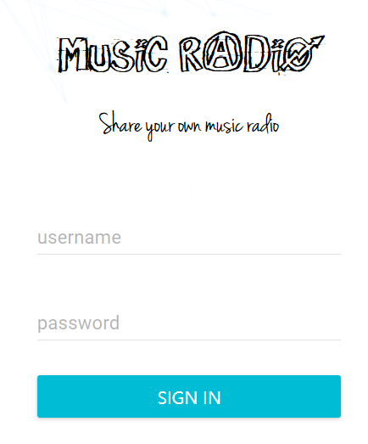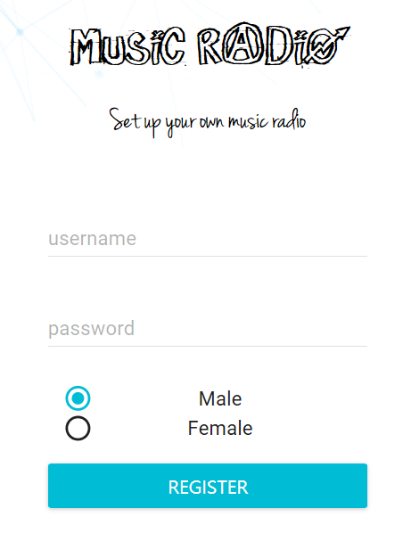

**Sign in & Sign up** (picture 1, 2)

Now you enter the music radio, and go to your ***Home***. Here you can upload your avatar, have a look at your liked song list and created song list. You can see the number of your friends as well.***(picture 3 down)***

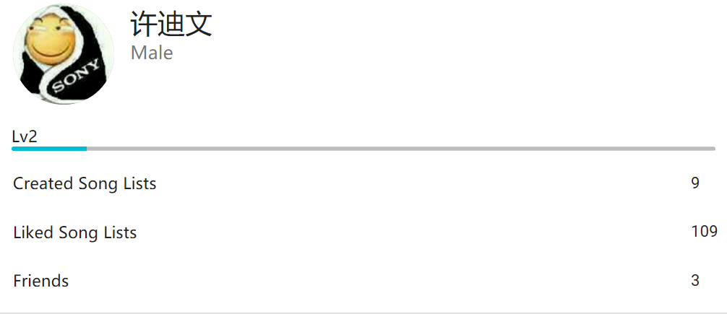

**User’s Home** (picture 3)

The Menu is on the left top of the page. So you can click on the button and a menu will come to your eye. ***(picture 4 down)***

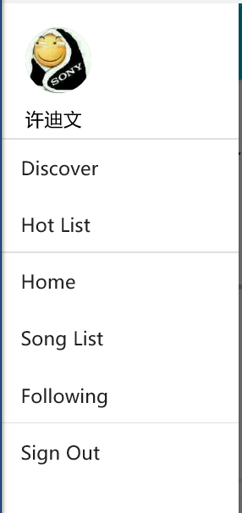 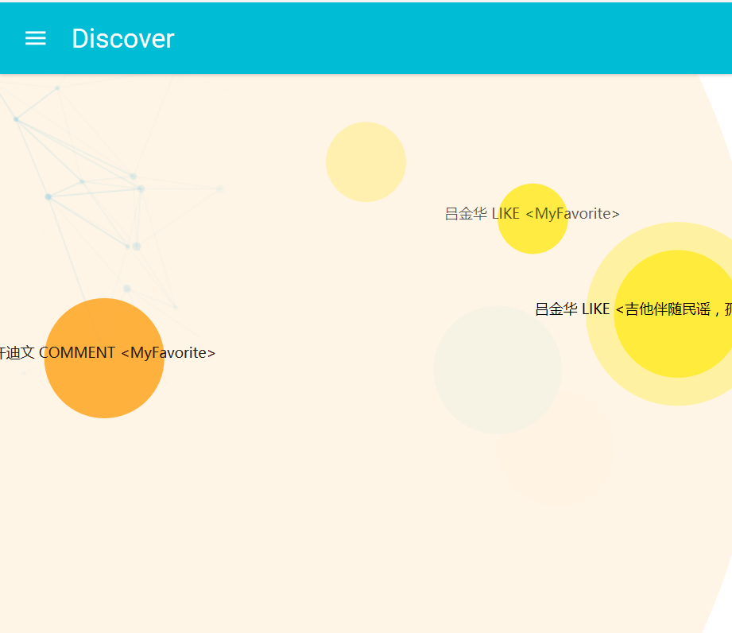

**Home** (picture 4) **Discover** (picture 5)

Firstly, you can go to the ***Discover***where you see a lot of song list made by others ***(picture 5 above).*** When you click the bubble emerge from the picture, the owner of the song lists appear ***(picture 6 down).***

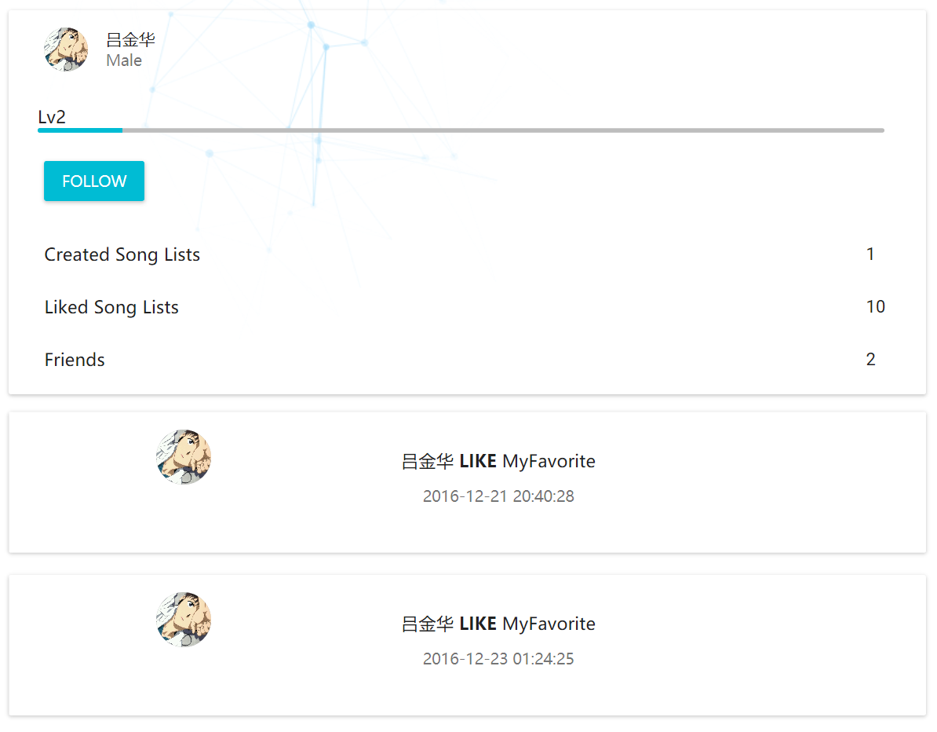

**Owner’s page** (picture 6)

If you are interested in the song list, you can click the star of the song list or the song in it to show your taste ***(picture 7 down)***. Also you can add the song and comment your song list for sure. You can comment it and share your emotion with others. It’s a way to encourage others to introduce more good songs and make more list. Sometimes you can see some funny comments when you get all the comments.

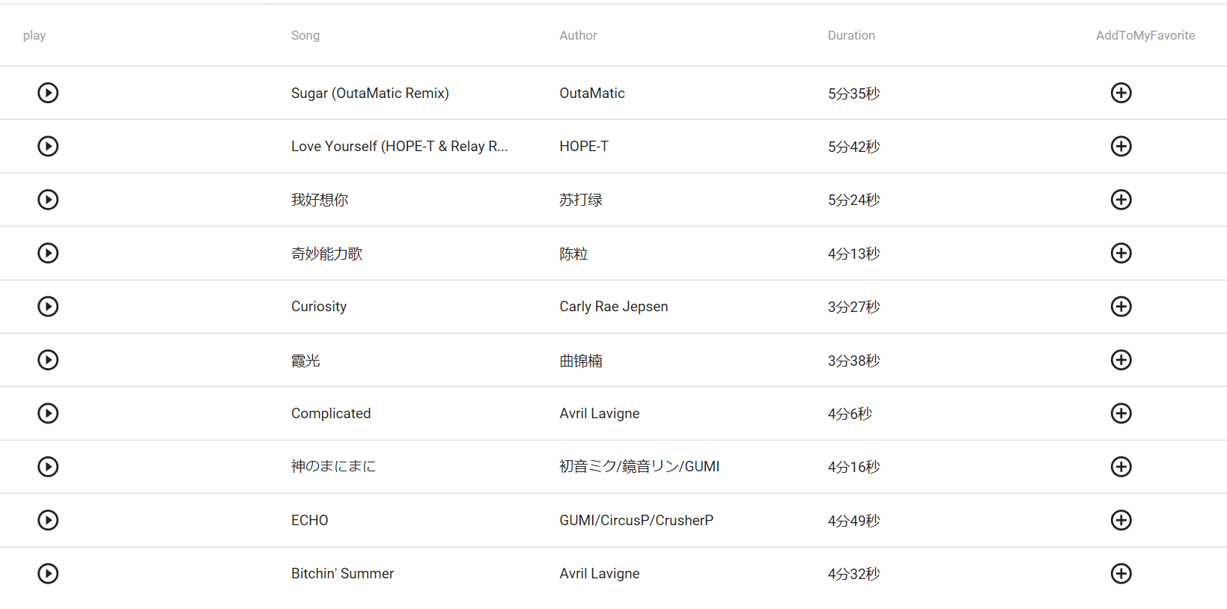

**Add To My Favorite** (picture 7)

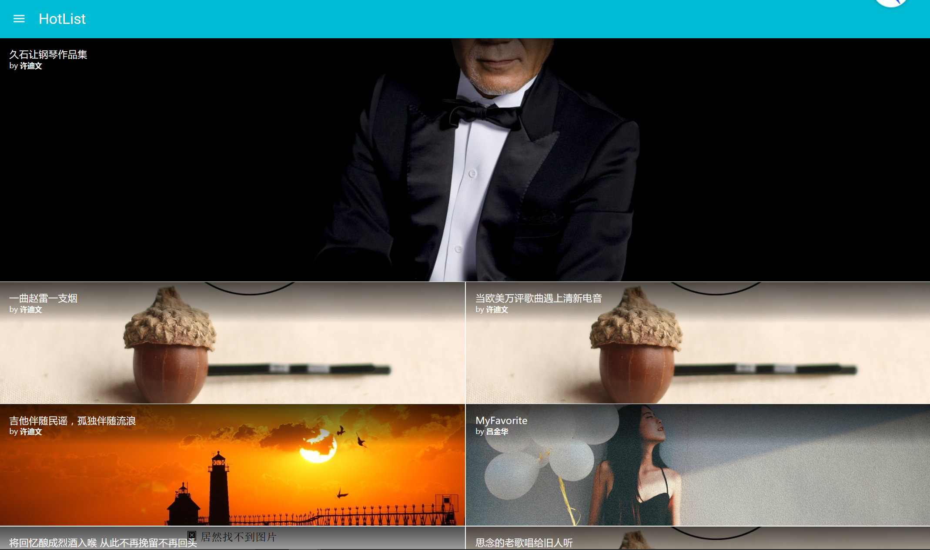

**Hot List** (picture 8)

***Hot List*** is the popular song list. You can see their rank ***(picture 8 up)***. People click the stars to show their appreciation. And you can listen to the song and follow their maker. Oh, I almost forget it, you can see your followers in ***Following.(picture 9 down)***

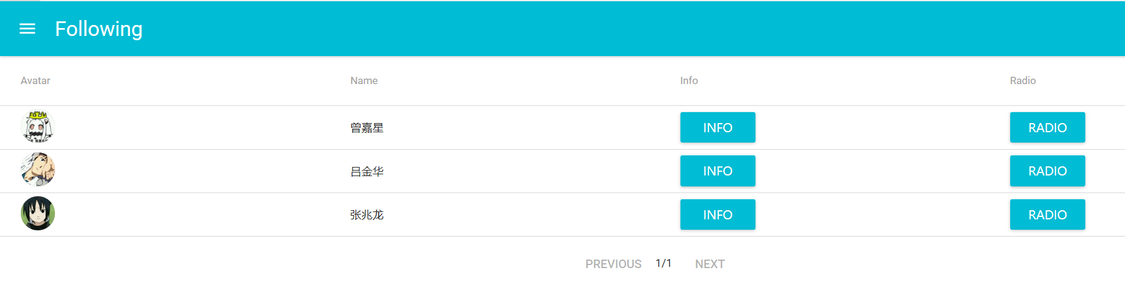

***Following*** *(picture 9)*

Music radio will recommend someone whose taste seems alike to yours. You can make friends with them after you click follow. ***(picture 10)***

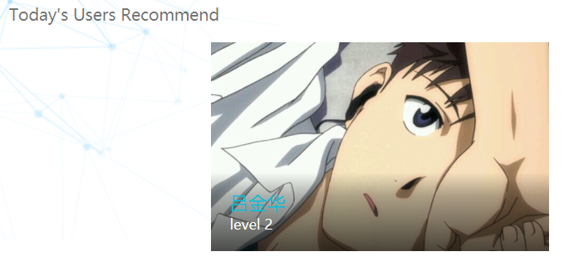

**Recommend user** (picture 10)

After listening to others’ music, I think you are engaged to make your song lists. Don’t be impatient, you haven’t know how to get songs. First you need to add a new song list, just like picture 11.

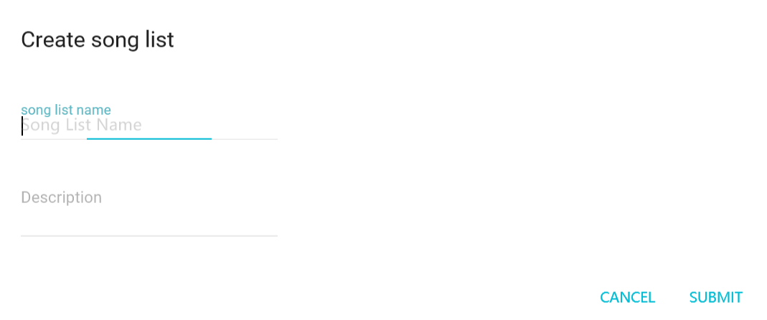

**Create song list** (picture 11)

Then you can search songs by name, upload your song and add from others’ song list. (picture 12)

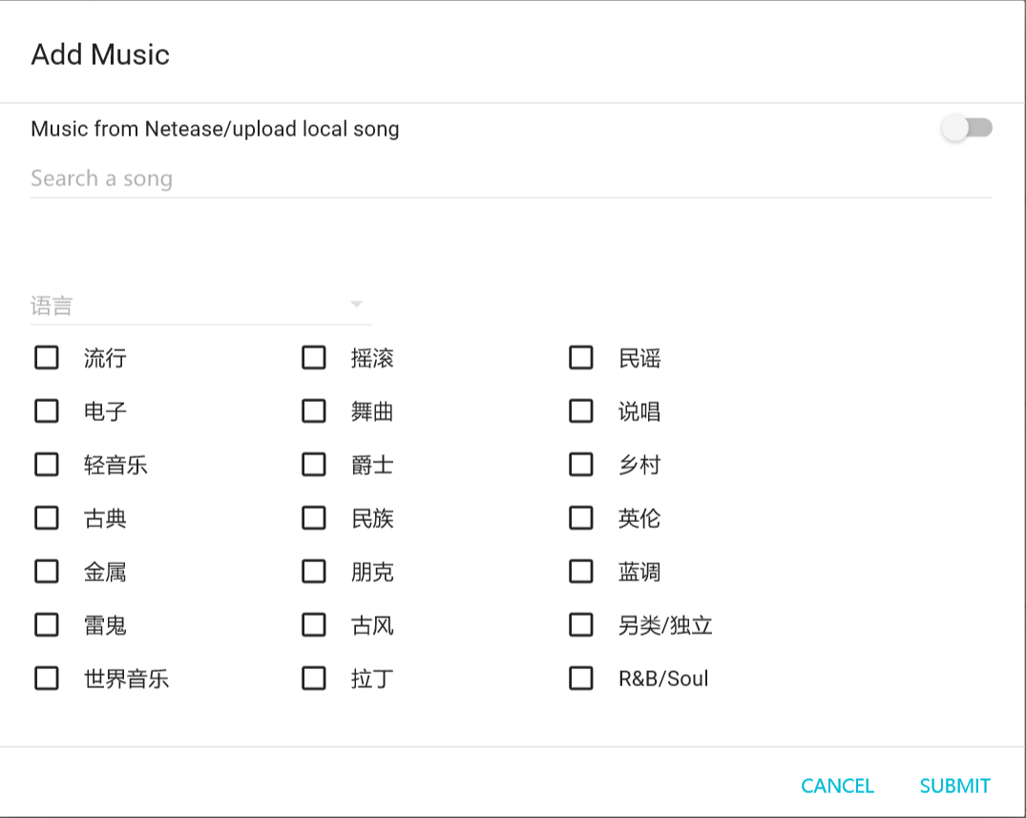

**Add music from Netease or local** (picture 12 i)

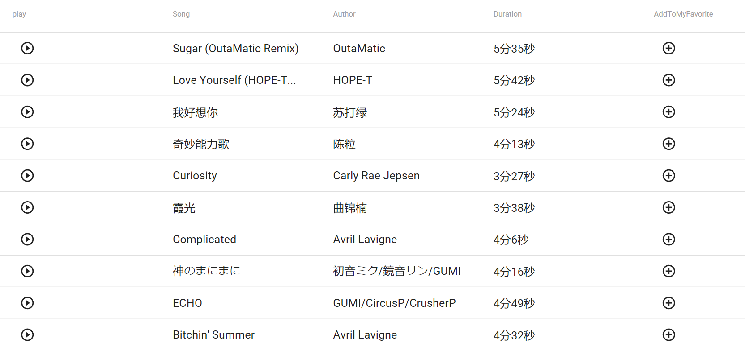

**Add music from other’s song list** (picture 12 ii)

After you look for a song, you can get the information and the lyric of it. In addition, Music radio will recommend songs according to the songs you have listened to. ***(picture 13)***

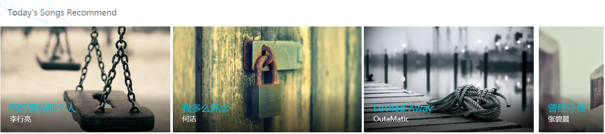

**Recommend songs** (picture 13)

After you add a new song, you can attach a picture to it. If you have added a song by mistake, you can also delete it.***(picture 14)***

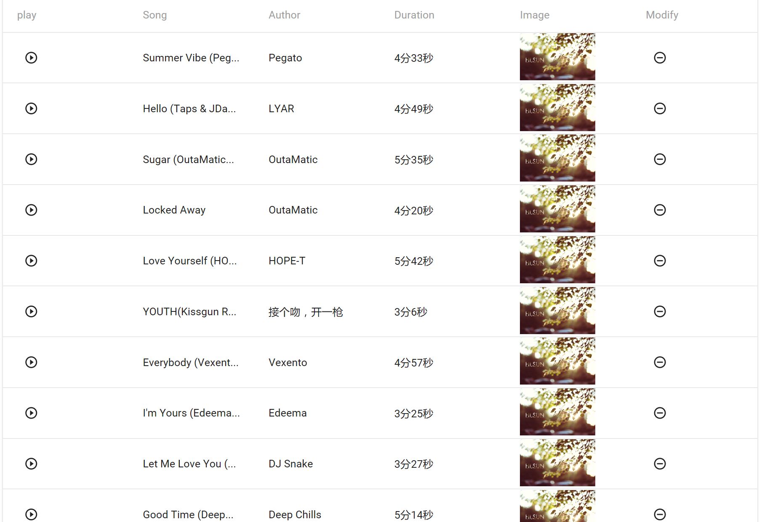

**Delete songs** (picture 14)

***Music List*** is the last but also important part of our project. You can make song list here, add songs, delete songs and play all songs. ***(picture 15 down)***Do whatever you like. But don’t forget to add a background picture to each of your song list. You can change the information as much time as you like. It should be noticed that, after you create a song list, it will appear in the ***Discover.*** So you can share your emotion with others. After having a good time in music radio, you can sign out.

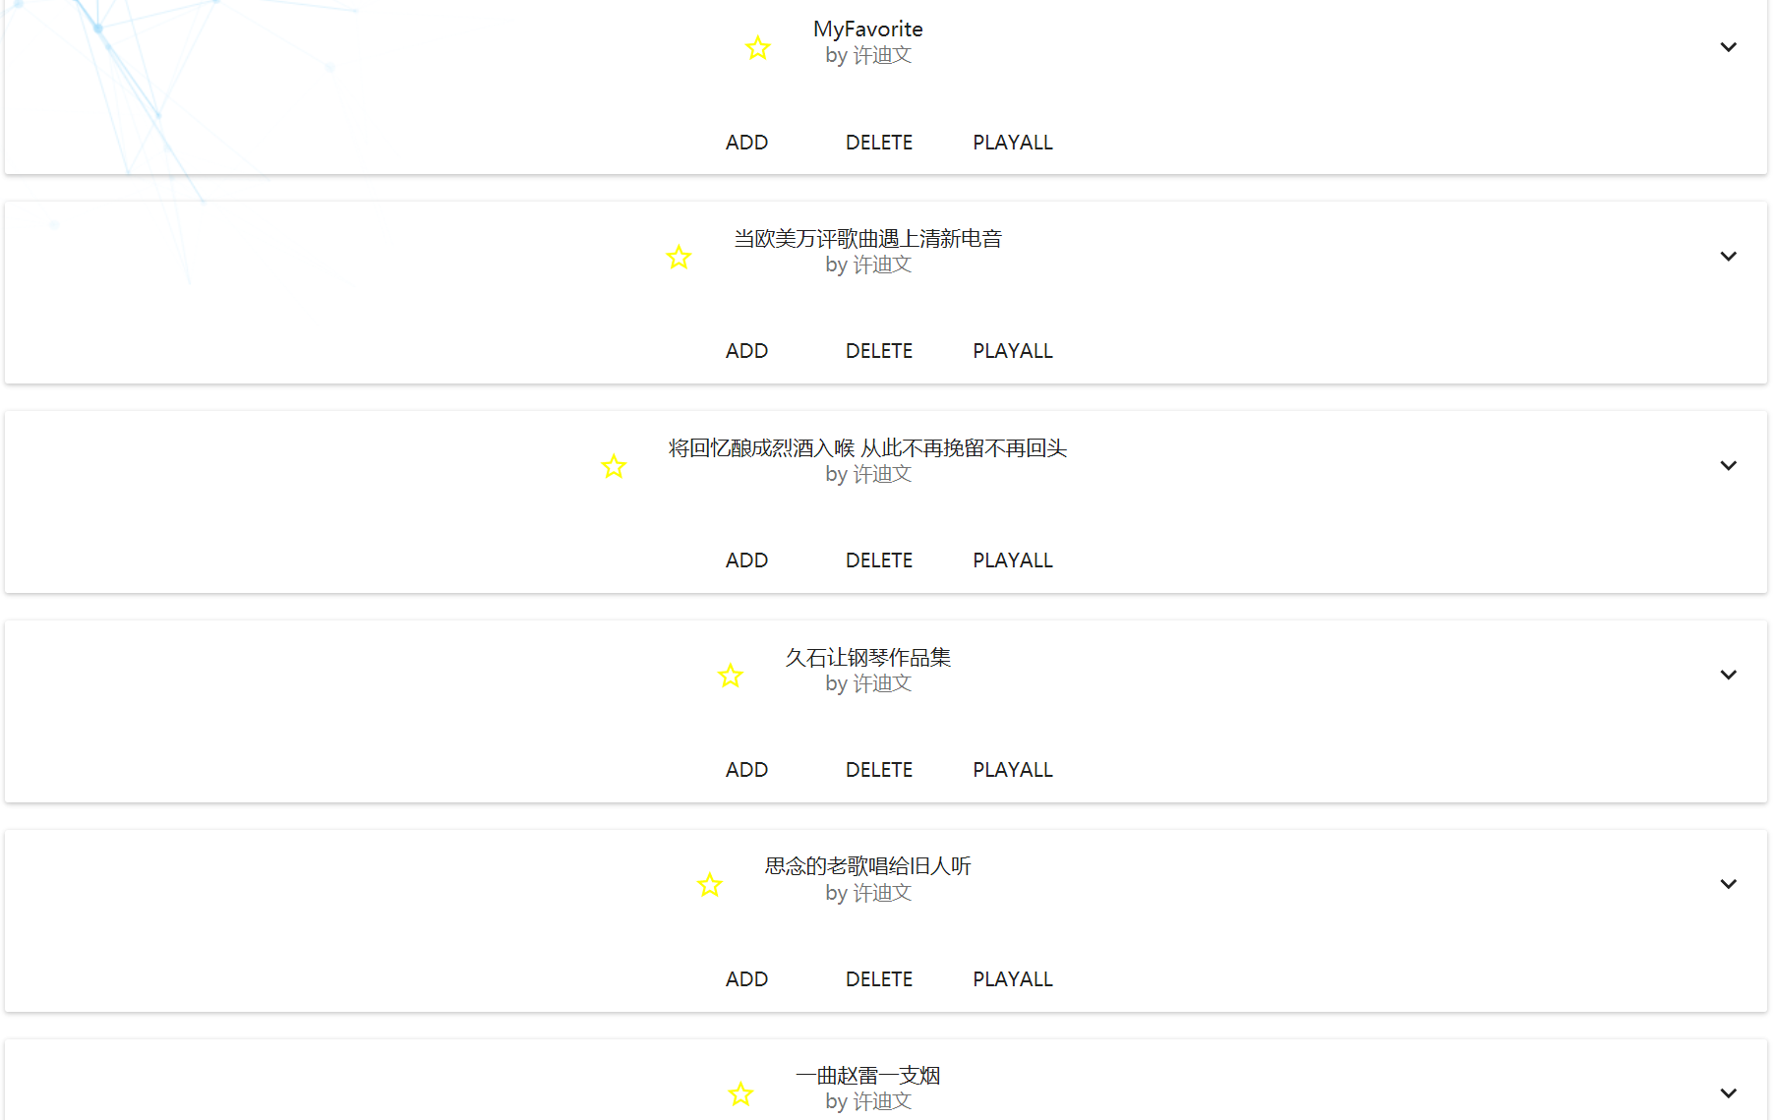

**Music list** (picture 15)

System architecture and component design

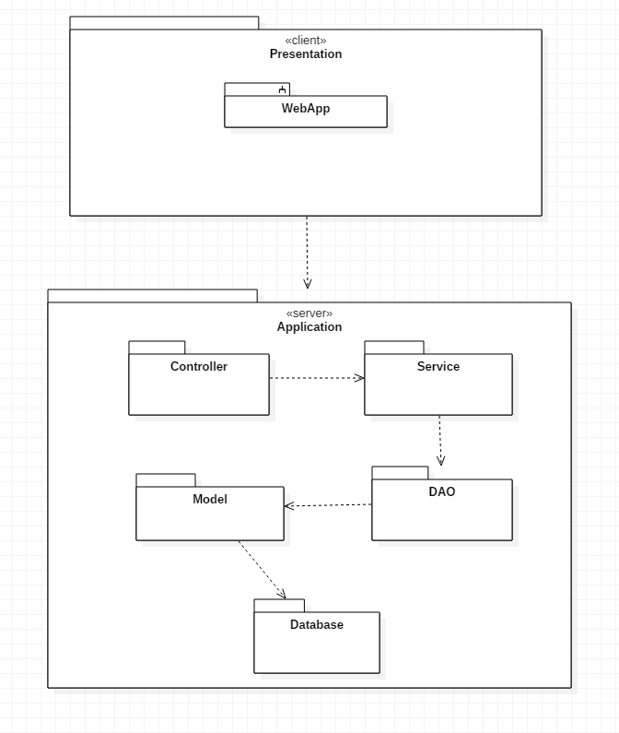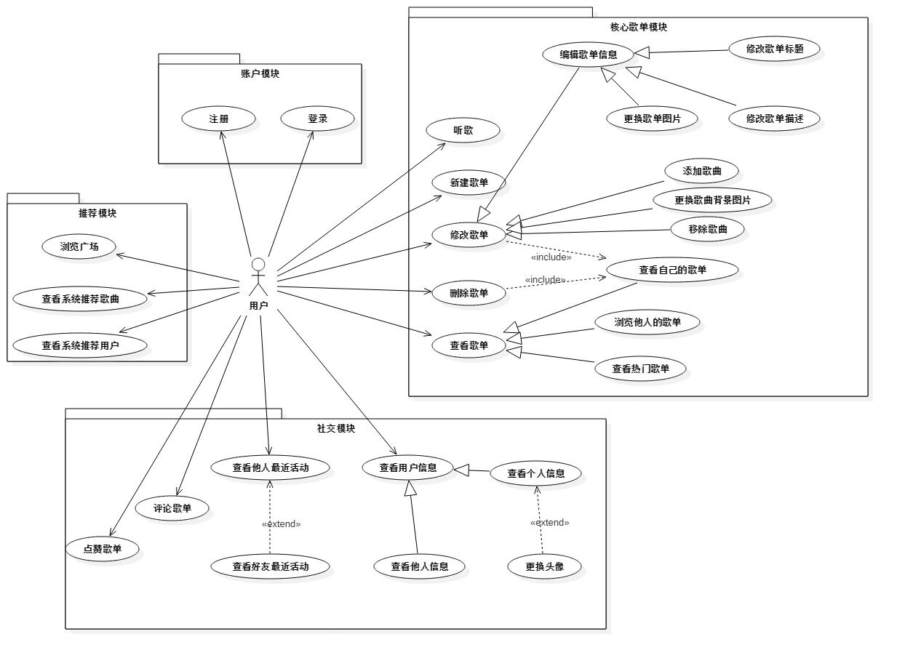

Database design

**Here is our ER diagram**

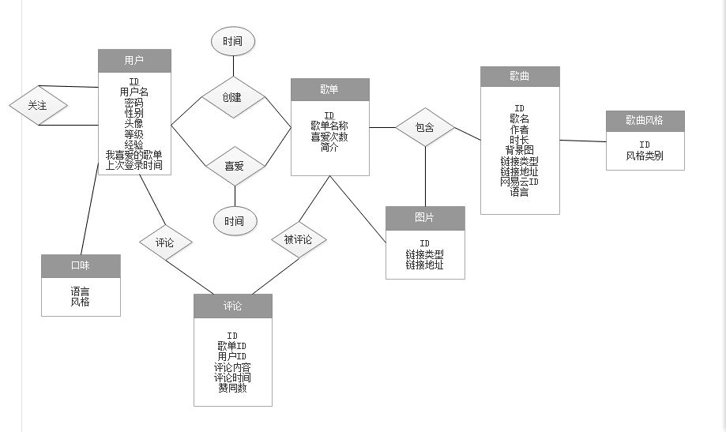

### User table

|  |  |  |
| --- | --- | --- |
| Name | Data type | Description |
| user_id | int |  |
| user_name | varchar(100) |  |
| passwd | varchar(128) |  |
| image_id | int | Avatar’s id |
| rank | int | Users’ Rank |
| experience | int | Users’ experience |
| sex | char(1) |  |
| list_id | int | favorite songlist id |
| last_signin | TimeStamp | Time user last sign in |

### SongList表

|  |  |  |
| --- | --- | --- |
| Name | Data type | Description |
| list_id | int | Songlist ID |
| list_name | varchar(100) | Songlist name |
| likes | int | Time people likes |
| image_id | int | Image_id of songlist |
| profile | TEXT(65536) | Songlist description |
| user_id | int |  |
| create_time | TimeStamp |  |

### Song表

|  |  |  |
| --- | --- | --- |
| Name | Data type | Description |
| song_id | int |  |
| song_name | varchar(100) |  |
| author_name | varchar(100) |  |
| last_time | varchar(10) | Whole time of a song |
| song_uri | varchar(255) |  |
| song_type | char(1) |  |
| netease_id | int |  |
| language | varchar(45) |  |
| styles | varchar(45) |  |

### 

### Image表

|  |  |  |
| --- | --- | --- |
| Name | Data type | Description |
| image_id | int |  |
| image_uri | varchar(255) | Source url |
| image_type | char(1) | Type of source |

### Comment表

|  |  |  |
| --- | --- | --- |
| Name | Data type | Description |
| comment_id | int |  |
| user_id | int | Comment user’s id |
| list_id | int | Commented songlist |
| content | varchar(65535) |  |
| comment_time | TimeStamp |  |
| likes | int |  |

### 6．Prefer表

|  |  |  |
| --- | --- | --- |
| Name | Data type | Description |
| user_id | int |  |
| list_id | int | Songlist_id |
| prefer_time | TimeStamp | Time people likes |

### 

### Contain表

|  |  |  |
| --- | --- | --- |
| Name | Data type | Description |
| list_id | int | Songlist id |
| song_id | int |  |
| image_id | int |  |

### Follow表

|  |  |  |
| --- | --- | --- |
| Name | Data type | Description |
| f_id | int | Table id |
| user_id | int | User A_id |
| follow_id | int | User B_id |

### Style表

|  |  |  |
| --- | --- | --- |
| Name | Data type | Description |
| style_id | int |  |
| style_name | varchar(20) |  |

### Taste表

|  |  |  |
| --- | --- | --- |
| Name | Data type | Description |
| user_id | int |  |
| language | JSON | {“langs”:[0,0,0,0,0]} |
| style | JSON | {“styles”:[0,0,0,0`````]} |

Recommend algorithm

Suppose the feature vector of songs Vs and the style of songs which we list 21 of it. If the song has the same kind of style, then the digit is 1.

Feature vector of the song Vs = [S1, S2, S3, S4……S21] T, Si∈ {0, 1} (1≤ i ≤21).

Suppose a user’s feature vector Vu, Vu =si, Si indicate the song user listened to in the past few days. Then how to recommend the songs?

We define the possibility the user probably likes angleV = cosθ,

angleV = (Vw is the transposed matrix of Vu, while Vt is the transposed matrix of Vs)

So to the same user V, Vu is the same value. Then we define valuation of recommendation = Vu Vw**╳**angleV = = Pro Vu Vs